DATA ANALYYICS WITH TABLEAU
SUPERMARKET SALES ANALYTICS REPORT
ASSIGNMENT-1

- SALES BY CUSTOMER TYPE

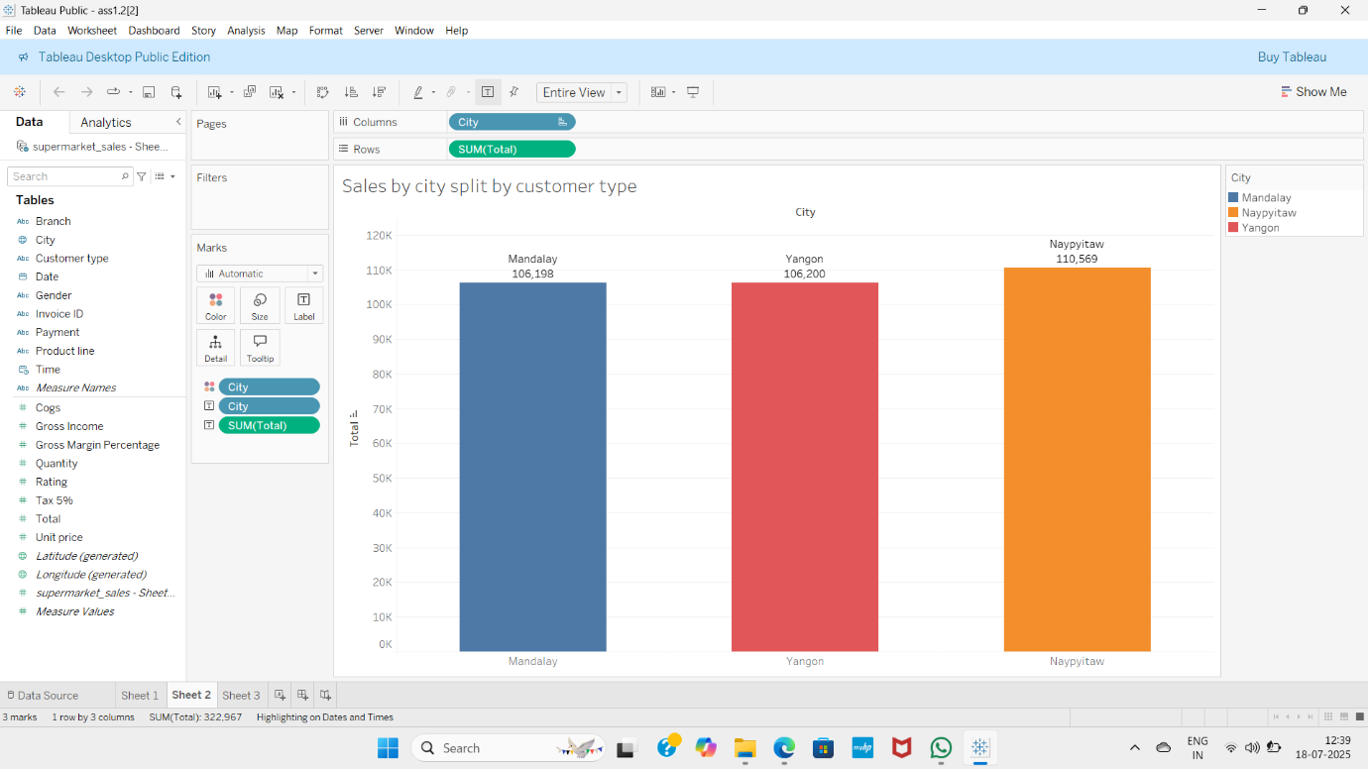

- DISTRIBUTION OF PAYMENTS METHODS
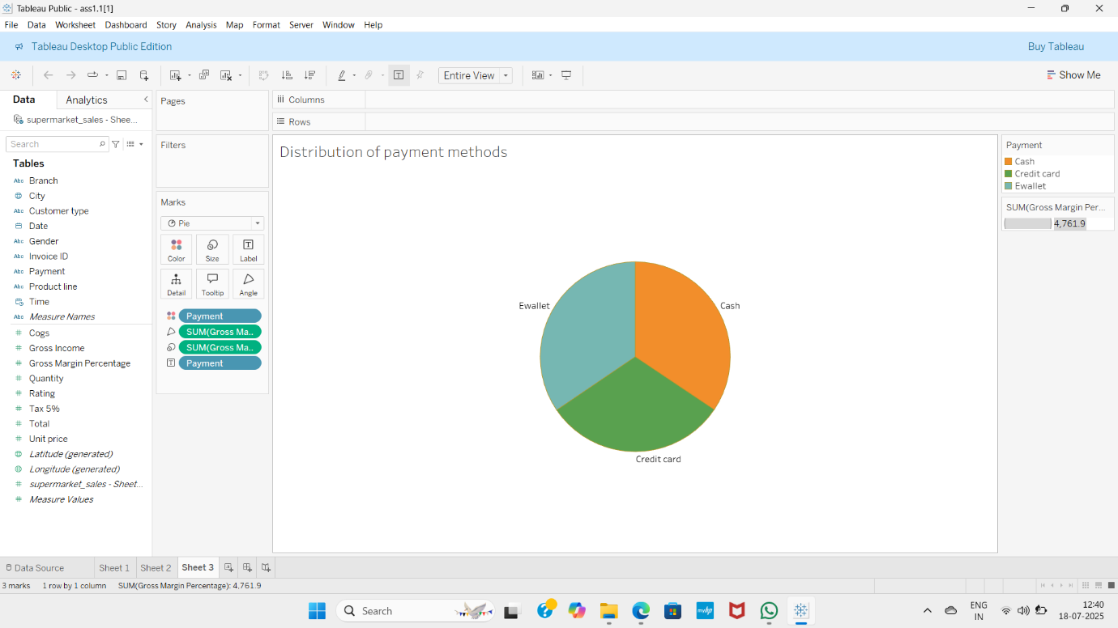

3. TOTAL SALES BY PRODUCT LINE

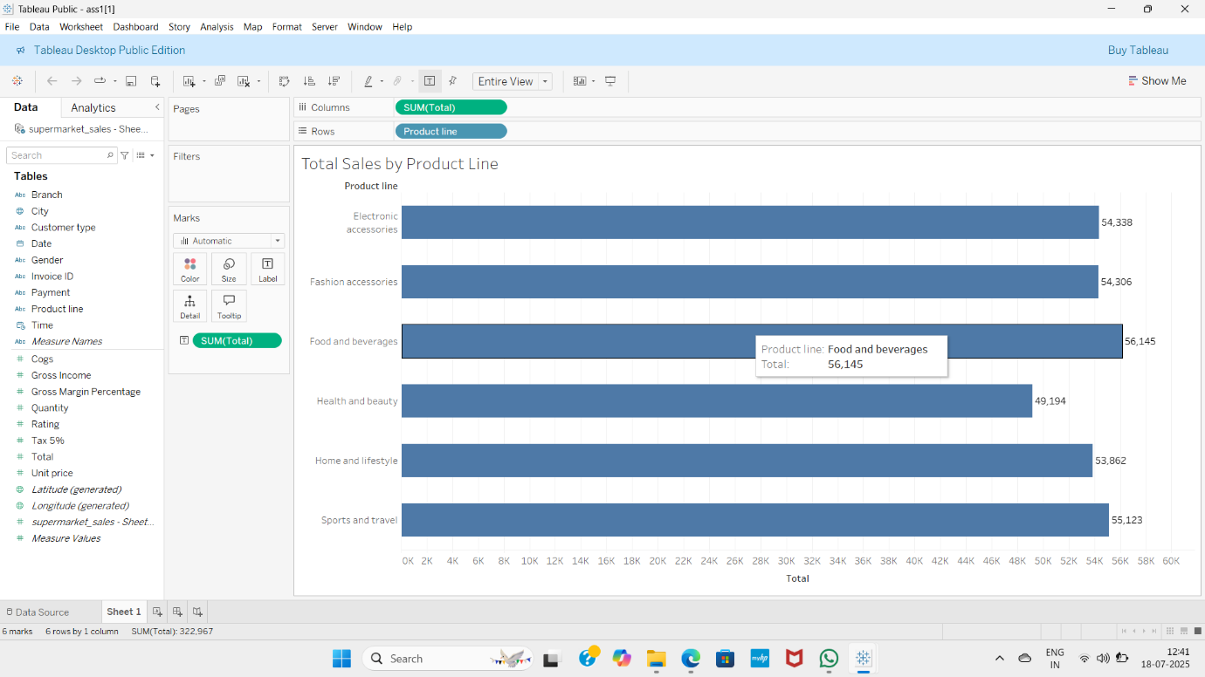
4.TOTAL SALES OVER TIME
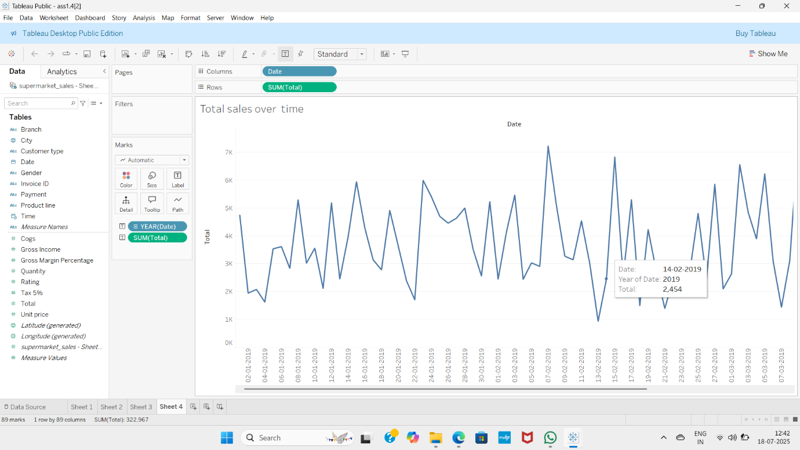

DATA ANALYTICS WITH TABLUEAU
SUPERMARKET SALES ANALYTICS REPORT
ASSIGNMENT-2

1.SALES BY PRODUCTLINE BY CITY
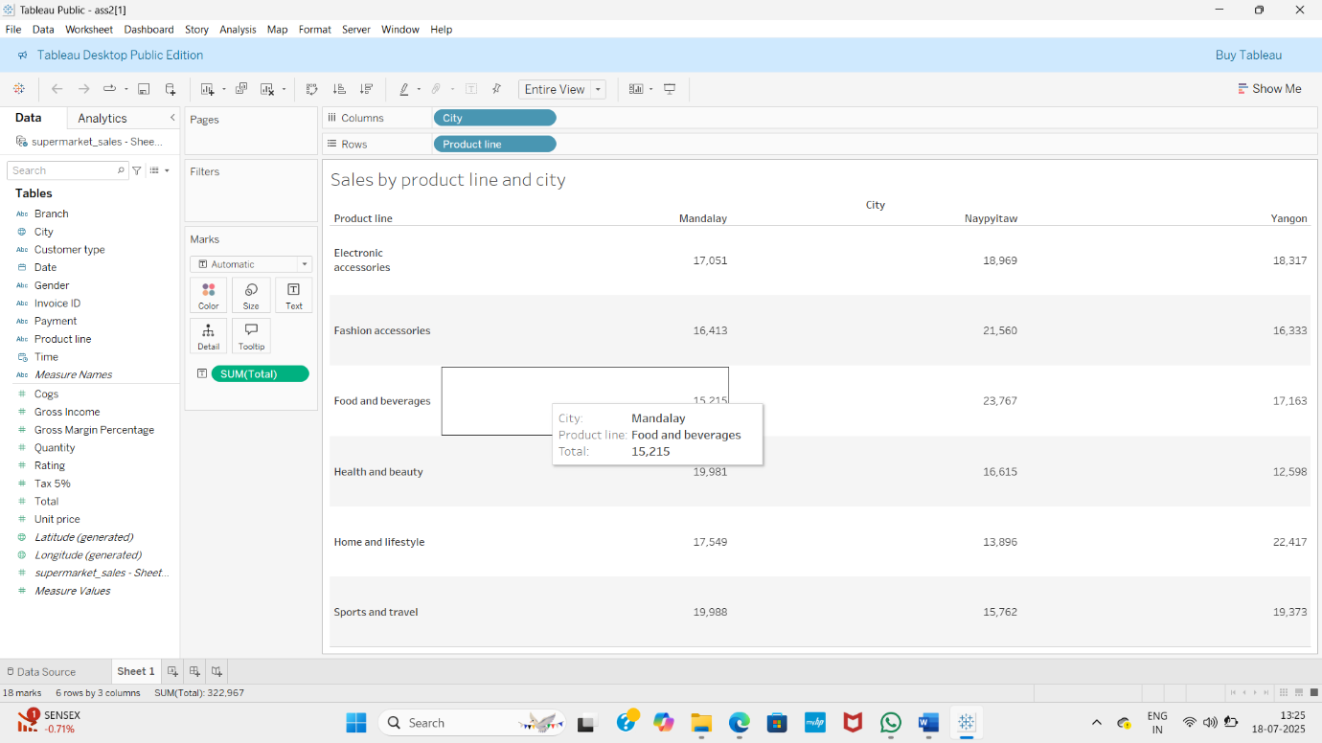

2.AVERAGE RATING BY BRANCH AND GENDER

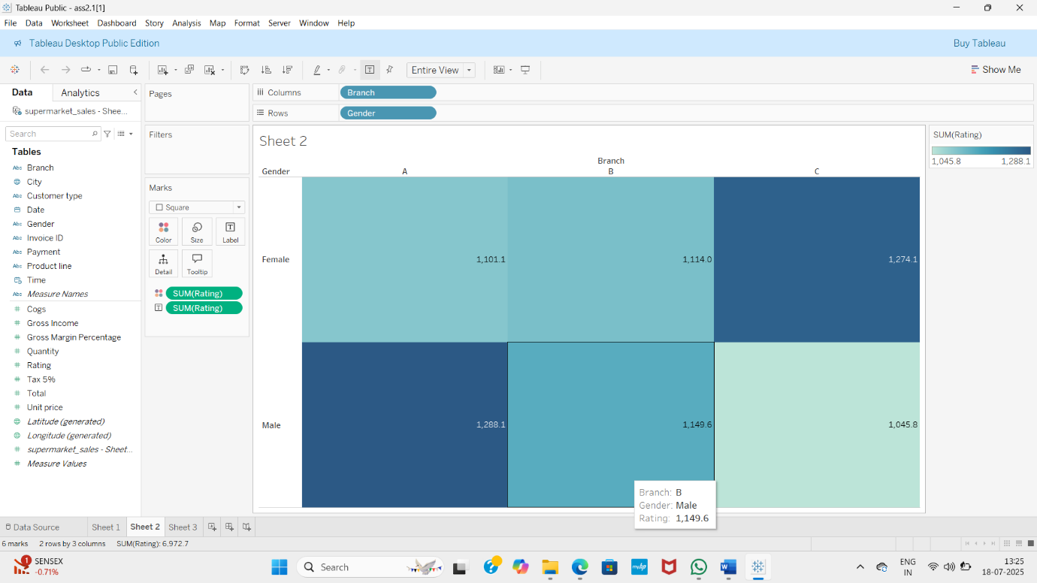

3.TOTAL SALES OVER TIME

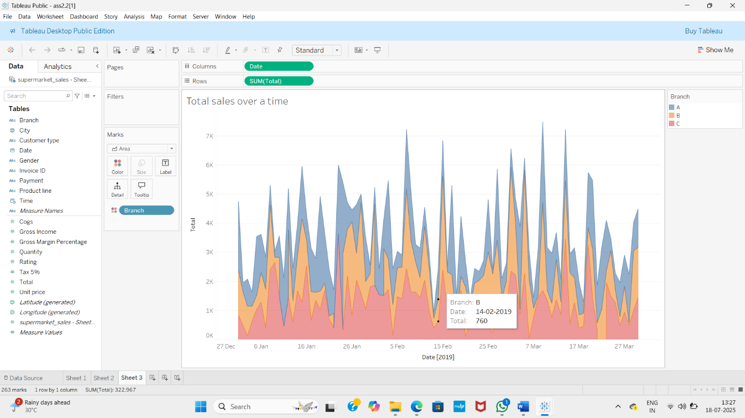

4.PRODUCT POPULARITY
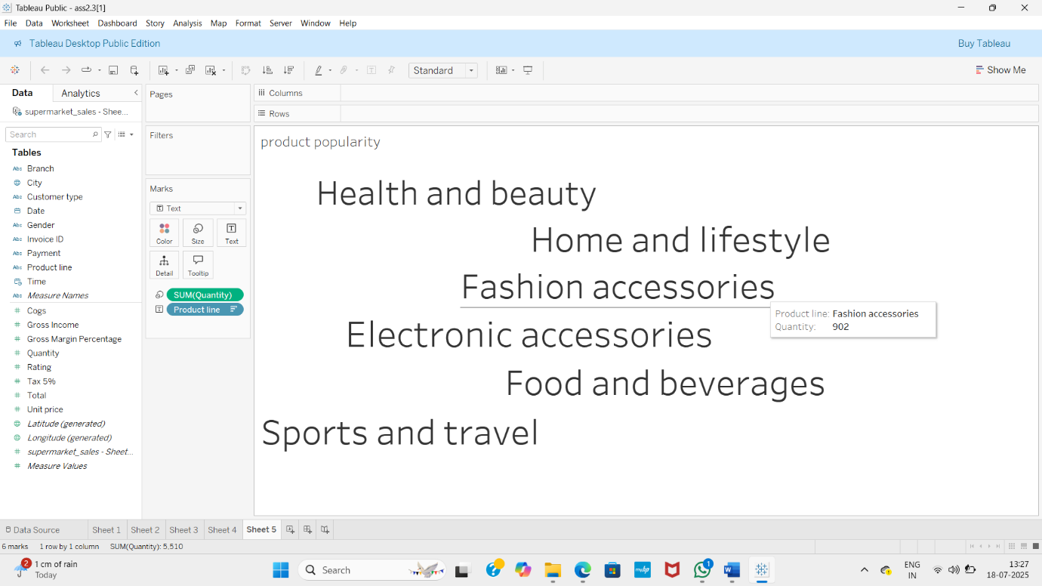
DATA ANALYTICS WITH TABLEAU
SUPERMARKET SALES ANALYTICS REPORT
ASSIGNMENT-3
1.DASHBOARD-1
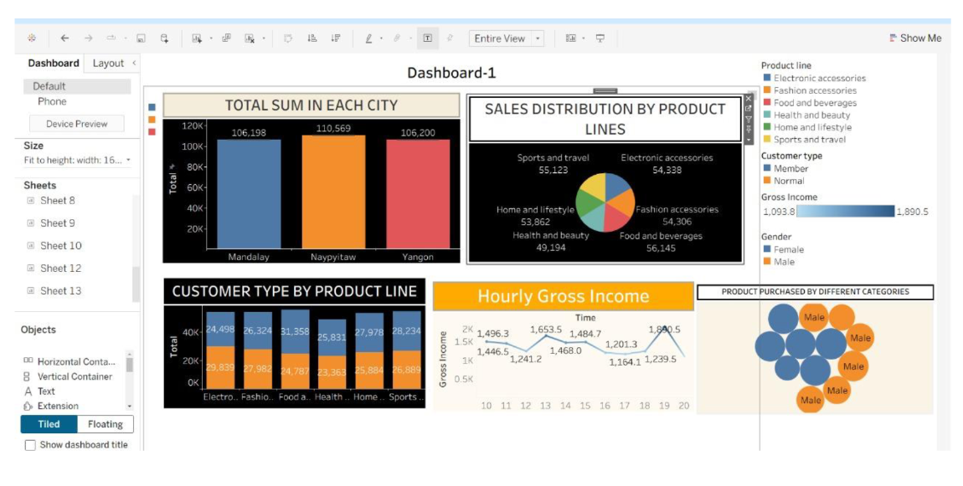

2.DASHBOARD-2
